Task 1

#include<iostream>

using namespace std;

int add(int, int);

int mult(int,int);

int div(int,int);

int mod(int,int);

int sub(int,int);

int main()

{

int divi,mul,sum,modi,subt,num1,num2;

cout<<"\nEnter number 1 : ";

cin>>num1;

cout<<"\nEnter number 2 : ";

cin>>num2;

sum=add(num1,num2);

cout<<"\nNo 1 : "<<num1<<endl<<"No 2 : "<<num2<<endl<<endl;

cout<<"addition : "<<sum;

subt=sub(num1,num2);

cout<<"\nSubtracttrion : "<<subt;

divi=div(num1,num2);

cout<<"\nDivision : "<<divi;

mul=mult(num1,num2);

cout<<"\nMultiplication : "<<mul;

modi=mod(num1,num2);

cout<<"\nRemainder : "<<modi;

}

int add(int n1,int n2)

{

int r=n1+n2;

return r;

}

int sub(int n1,int n2)

{

int r= n1-n2;

return r;

}

int div(int n1,int n2)

{

int r= n1/n2;

return r;

}

int mult(int n1,int n2)

{

int r=n1\*n2;

return r;

}

int mod(int n1,int n2)

{

int r=n1%n2;

return r;

}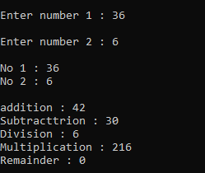

Task 2

#include<iostream>

using namespace std;

int square(int);

int main()

{

int num,sqr;

cout<<"\nENter the number to get square : ";

cin>>num;

sqr=square(num);

cout<<"\nSquare : "<<sqr;

}

int square(int no)

{

int sq;

sq=no\*no;

return sq;

}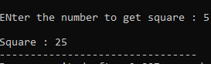

Task 3

#include<iostream>

using namespace std;

int grt(int,int);

int main()

{

int great;

int no1,no2;

cout<<"\nEnter first number : ";

cin>>no1;

cout<<"\nEnter the second number : ";

cin>>no2;

great=grt(no1,no2);

cout<<endl<<great<<" Is the greatest number";

}

int grt(int no1,int no2)

{ int grt;

if(no1>no2)

grt=no1;

else

grt=no2;

return grt;

}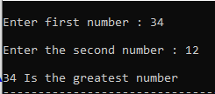

Task 4

#include<iostream>

using namespace std;

string check(int);

int main()

{

int num;

string res;

cout<<"\nENter any number : ";

cin>>num;

res=check(num);

cout<<"\nThe number is "<<res;

}

string check(int u)

{

string val;

if(u%2==0)

val="Even";

else

val="Odd";

return val;

}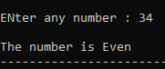

Task 5

#include<iostream>

#include<iomanip>

using namespace std;

float per(float,float);

int main()

{

float perc,total,obtained;

cout<<"\nENter the total marks : ";

cin>>total;

cout<<"\nEnter the obtained marks : ";

cin>>obtained;

perc=per(total,obtained);

cout<<"\nThe percentaeg is : "<<setprecision(2)<<fixed<<perc<<'%';

}

float per(float tot,float ob)

{

float perc=(ob/tot)\*100;

return perc;

}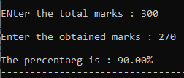

Task 6

#include<iostream>

using namespace std;

char grade(float);

int main()

{

float perc;

char grd;

cout<<"\nEnter your percentage : ";

cin>>perc;

grd=grade(perc);

cout<<"\nYour grade is "<<grd;

}

char grade(float perc)

{

char g;

if(perc>=80&&perc<=100)

g='A';

if(perc>=70&&perc<80)

g='B';

if(perc>=60&&perc<70)

g='C';

if(perc>=0&&perc<60)

g='F';

return g;

}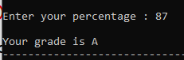

Task 7

#include<iostream>

using namespace std;

bool check(int);

int main()

{

int num;

bool test=false;

cout<<"\nEnter the number : ";

cin>>num;

test=check(num);

if(test==0)

cout<<"\nThe number is not even";

else

cout<<"\nThe number is even";

}

bool check(int no1)

{

bool tst=false;

if(no1%2==0)

tst=true;

else

tst=false;

return tst;

}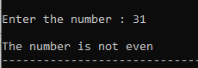

Task 8

#include<iostream>

int func(int);

using namespace std;

int main()

{

int range,sum;

cout<<"\nEnter the range : ";

cin>>range;

sum=func(range);

cout<<"\nThe sum of all "<<range<<" positive numbers is : "<<sum;

}

int func(int rng)

{

int sum=0;

for(int i=1;i<=rng;i++)

sum=sum+i;

return sum;

}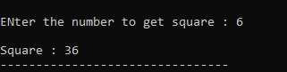

Task 9

#include<iostream>

void printTable(int);

void printTable(int,int);

using namespace std;

int main()

{

int num,num1,range;

cout<<"\nEnter the number to print its table : ";

cin>>num;

printTable(num);

cout<<"\nEnter the number to print its table : ";

cin>>num1;

cout<<"\nEnter the range to print : ";

cin>>range;

printTable(num1,range);

}

void printTable(int no)

{

for(int i=1;i<=10;i++)

cout<<i<<" x "<<no<<" = "<<i\*no<<endl;

}

void printTable(int num,int range)

{

for(int i=1;i<=range;i++)

cout<<i<<" x "<<num<<" = "<<i\*num<<endl;

} 